**XIOTAS SOLAR DRYER MONITORING AND AUTOMATION PROJECT (PROTOTYPE)**

---------- Welcome to the family of XIOTAS products. Thanks for choosing XIOTAS product ----------

This SOLAR DRYER MONITORING AND AUTOMATION PROJECT is capable of monitoring the dryer environment and controlling equipment remotely from an android device in almost real time. Using android application, we can monitor the temperature and humidity of 3 dryer room environments simultaneously. Also, up to 5 devices we can connect to the output and control from the android app. For the ease of use, here introduced local control buttons for each output. Both local and remote control are well synchronized. So, the change is reflected on the app in real time. In addition to that in the app there is one feedback status for each output to double ensure current status of each output. Sometimes remotely operated devices will cause accidents. To avoid these kinds of accidents here introduced a warning alarm before turning each output. It will be a great breakthrough to ensure zero accidents. Easy LED status indication ensure easy understanding of device condition without any complexity. Inbuilt Wi-Fi and Bluetooth will avoid unwanted wiring for the networking. Inbuilt Li-ion battery will ensure un-interrupted operation of the device and make the device to sustain in any conditions. Aviation connectors are used in this device to ensure reliable connection between sensor and the device. Moreover, to that a well-designed enclosure make the device good for its user.

Key Features

* *Real time monitoring and remote controlling*
* *Temperature and humidity in a single sensor*
* *Local and remote control of devices*
* *Five output devices*
* *Warning alarm before output turning on*
* *Inbuilt Wi-Fi and Bluetooth*
* *Simple LED status indications*
* *Simple android app interface*
* *Inbuilt battery (8.4V)*
* *Unique device enclosure*

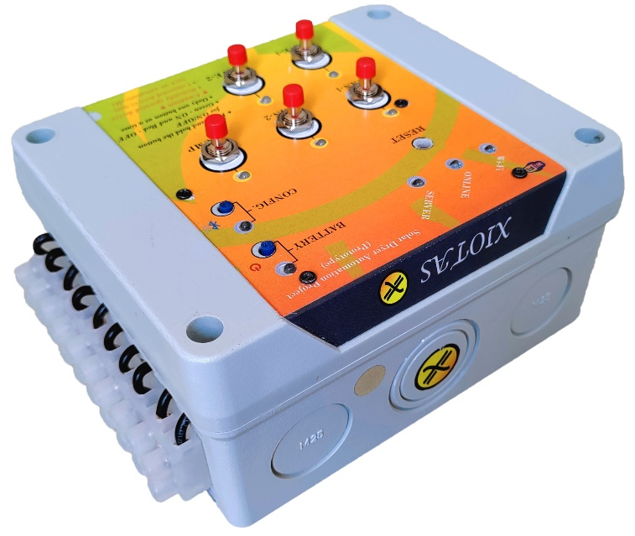

Figure 1 Prototype

**CHAPTER – 1 FAMILIARIZATION**

Below given images is showing all the necessary components.

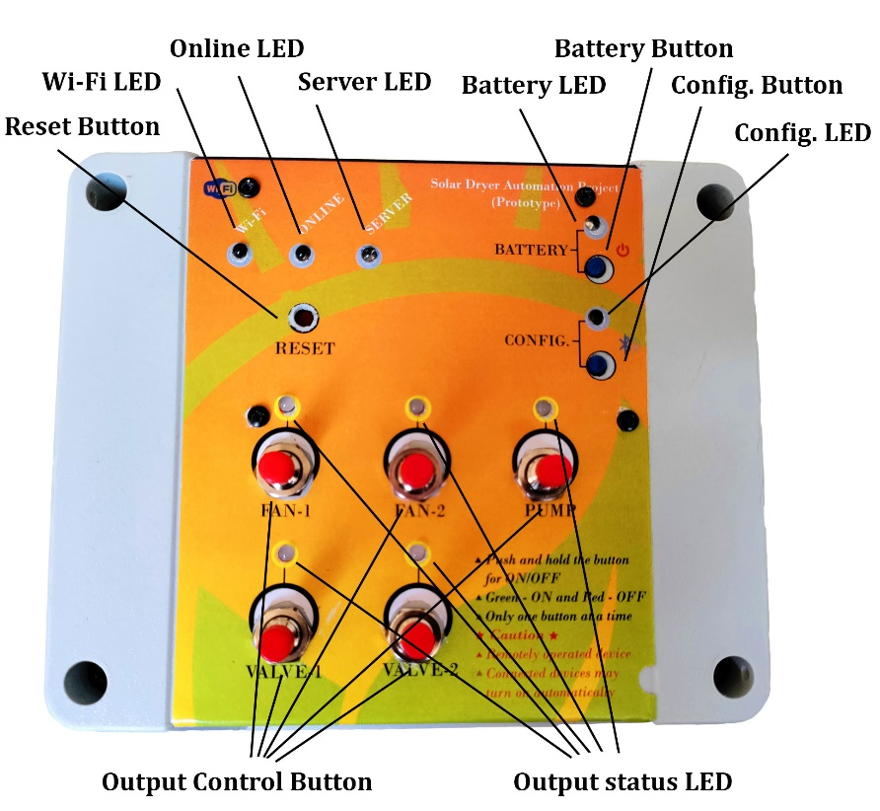

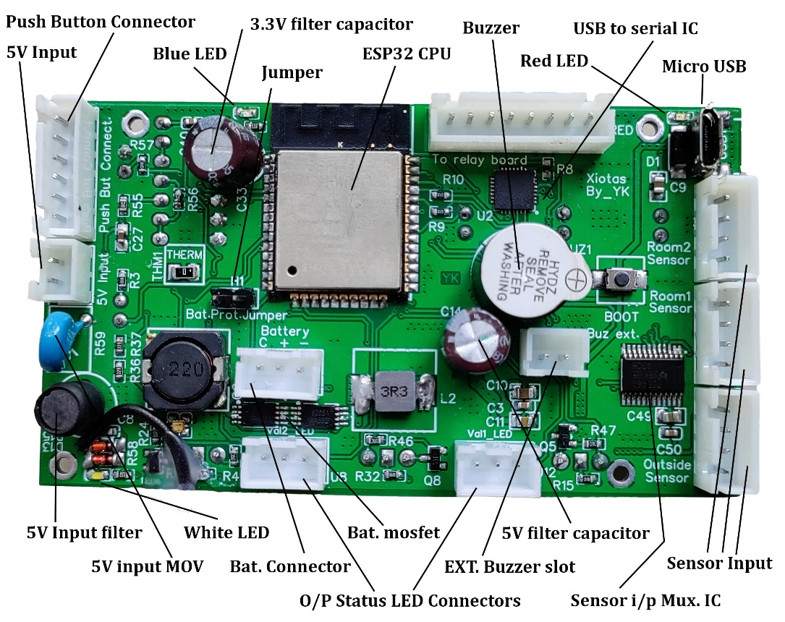

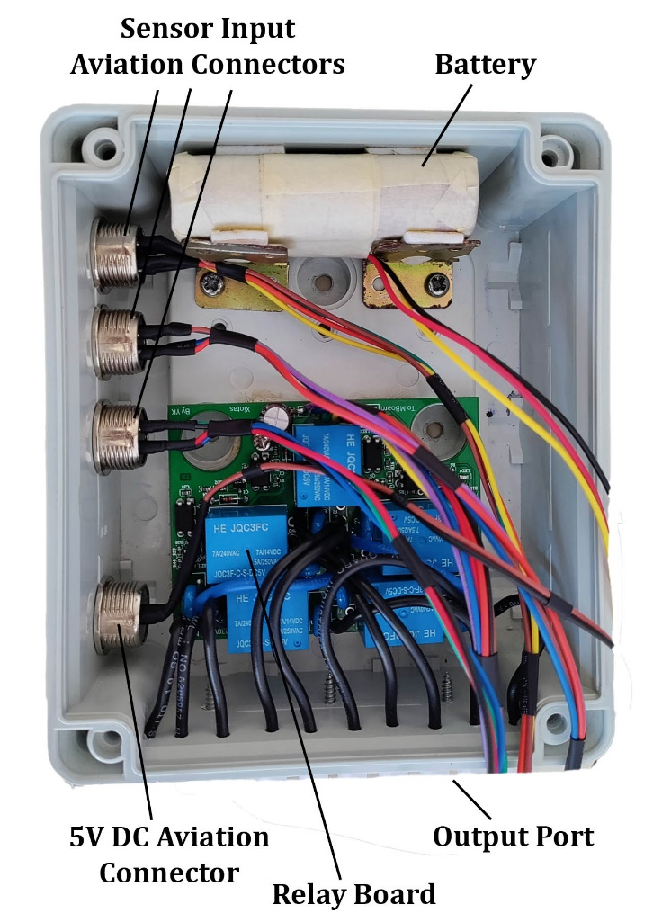

**CHAPTER – 2 OUTPUT INDICATIONS**

**2.1 LED Indications**

**Wi-Fi LED:** It is a Green LED indicating the status of Wi-Fi.

*One blink – Trying to connect to a Wi-Fi network.*

*ON – Connected to a Wi-Fi network.*

*OFF – Not connected to any Wi-Fi network.*

**Online LED**: It is a Green LED indicating the status of Internet.

*One blink – Checking internet availability.*

*ON – Internet is available.*

*OFF – No internet access.*

**Server LED:** It is a Green LED indicating the status of firebase server and uplink and downlink

activity.

*One blink – Successful reading (downlink) of data from firebase.*

*Two blink – Successful sending (uplink) of data to firebase.*

*ON – Connected to firebase server.*

*OFF – Not connected to firebase server.*

**Output status LEDs:** Total 5 bicolour (red and green) LEDs indicating status of outputs.

*Green – Corresponding output is ON.*

*RED – Corresponding output is OFF.*

*Blinking – Output will turn on Soon (Warning indication because it is remotely operated).*

*OFF – Indicating power failure.*

**Battery LED:** It is a Red LED. Indicating the status of battery backup.

*ON – Battery backup enabled. So, device will stay online and communicates with server*

*normally at the time of power failure. But all outputs are disabled in this condition.*

*OFF – Battery backup disabled. So, device will turnoff when power failure occurs. Reboot*

*when power restores.*

**Config. LED:** It is helping to do the Wi-Fi configuration (SSID and password) at the time of rebooting the system. It will turn on for few seconds at the time of booting (for booting just press reset button). In this time the config. Button is enabled. So, by pressing the button, the system will enter in to Wi-Fi configuration. The configuration is done via Bluetooth. So, when pressing the button also will turn on the Bluetooth.

*ON: Config. Button enabled.*

*Blinking with period of .4 sec: Entered into config. section you can give SSID*

*(Wi-Fi name) now.*

*Blinking with period of .2 sec: You can give Wi-Fi password now.*

**Internal LEDs (Onboard LEDs)**

**White LED:** Indicating availability of 5V. It will turn on when external 5V is available or 5V from

USB is available.

**Red LED:** Indicating 5V is available from USB.

**Blue LED:** Indicatingavailability of 3.3V.

**Red LEDs on Relay Board:** Indicating status of output channels.

ON: Corresponding channel is OFF (relay off)

OFF: Corresponding channel is ON (relay on)

**2.2 Sound Indications**

**Buzzer:** When output is changing from OFF condition to ON condition, first the buzzer will get start buzzing to give warning for few seconds. Then only output enables. The warning is because the output operating is from a remote location, so it will reduce accidents.

**CHAPTER – 3 BUTTON INPUTS**

**Reset Button:** It is for rebooting the system. If system is not working properly press the button for resetting everything once again. Also press the button before setting the Wi-Fi configuration. For avoiding unwanted activation, it is placed little inside. So, recommended to use small screwdriver on any such tool for its operation.

**Battery Button:** It is for activating the battery backup. If it is activated the system will work normally on power failure. But all the outputs are disabled on power failure. Outputs set to the old status automatically when power came back.

**Config. Button:** It is for entering into Wi-Fi configuration menu. It is enabled only when the config. LED is in ON condition.

**Output Buttons:** Total 5 push buttons are there which are using to control the outputs locally and it works without internet. Each one is for corresponding outputs. It is not a single push operation, for its activation press and hold the button for few seconds. If the output is in ON condition, then pressing and holding the button will change it into OFF condition and vice versa. The local operation is also reflecting in the android application if the internet is there otherwise updating once internet is there.

**CHAPTER – 4 SENSOR INPUTS AND 5V INPUT**

There are 3 sensors (SHT20). Each one is working on I2C protocol at 3.3V. Connection and disconnection of sensors in-between operation is not causing any problem. It will automatically detect the sensor and start reading the sensor. If it causes any problem, reboot the system using reset button. Each sensor is capable of sensing temperature (5-100*C) and humidity (10-100%).

The power input is 5V/2A. If the adaptor fails, buy a new one and connect the positive and negative rails in the correct way as did in the old one. Normally RED wire is positive and BLACK wire is negative. *If the polarity changes system has an internal reverse polarity protection diode which will short the input and protect the CPU. If it connected in wrong polarity for longer duration the diode may burnout and it may damage the entire PCB.*

***Note:*** *The sensor connectors are aviation connectors (GX16). They have polarity, check the groove and insert accordingly and tight it securely.* ***Do not pull the connector on the cable. It will damage the connection. Unscrew the nut and pull the connector alone using the nut.***

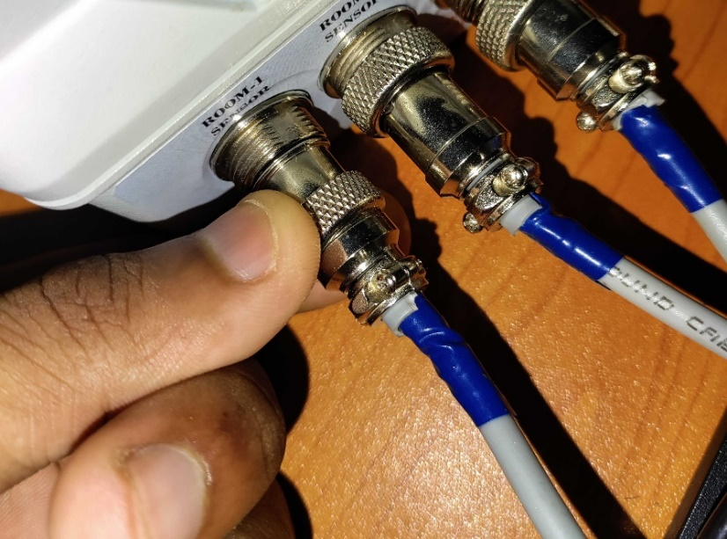***The below given image shows the correct way to pull out the connector. Pull the connector using the NUT.***

NUT

**CHAPTER – 5 OUTPUTS**

Total 5 outputs are there which is controlled by inbuilt electromagnetic relays. It can capable of controlling 230V AC devices with maximum current of 5A. All the outputs are protected using MOV (against surges). These outputs can be controlled by both locally and remotely (both are synchronised). The wiring diagram is given below. The relay switching is happening only on phase line. The normally open contact of relay is used here to produce output when relay get energized. The neutral is shorted (COM and N is internally shorted). So, avoid interchanging of input phase and neutral lines.

*Caution: It is important to connect input phase and neutral line in correct polarity. Otherwise, it may cause electric shock on output irrespective of the output state.*

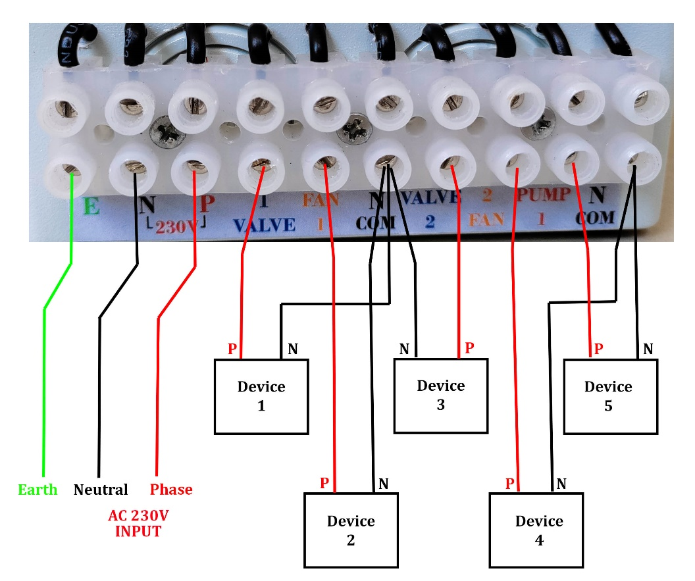

**CHAPTER – 6 SYSTEM DESCRIPTION**

ESP32 microprocessor is the heart of the system. It contains inbuilt Wi-Fi and Bluetooth radio. So, it makes the whole system reliable and compact. The processor is a dual core processor. So, the system is capable of running two tasks simultaneously. Here core two is dedicated for high priority tasks like reading input button and changing output states. So, these tasks will execute at very fast without any delay. The core one is dedicated for all other processes. It may execute at low speed. But it will not affect the whole system performance. Some salient features of the system are given below.

* System will reboot automatically at every 24 hours. It is for avoiding any crash in the system. This will remove all the data stored in the memory except the program and the Wi-Fi credentials.
* The sensor data is sent to the firebase server in every 10 Sec.
* Reading data from the firebase server and sending feedback data to the firebase server will happen without any delay.
* 10 sec. buzzing period before turning on each output as a warning to avoid accidents.
* Press and holding interface for controlling outputs locally for avoiding operation of the outputs on accidental push action.
* Battery will give minimum of 20-hour backup.
* Output LEDs turn OFF on power failure to indicate power failure situation. Otherwise, it is red or green based on output condition.
* Low voltage and high voltage circuit parts are isolated using opto-couplers.
* Water proof enclosure ensure entering no water inside.
* Simple LED indicator interface simplifies the interface and avoid confusion to the user.
* Dedicated manual reboot button for restarting the system at any event to recover the system functionality back.

Check the video for more information. Video link is given below.

<https://drive.google.com/file/d/1-4DQNT6GsEt5CJUVaioUJyy7v-bJd_sG/view?usp=sharing>

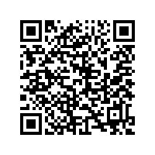

The below flowchart represents the simple working flow of the system.

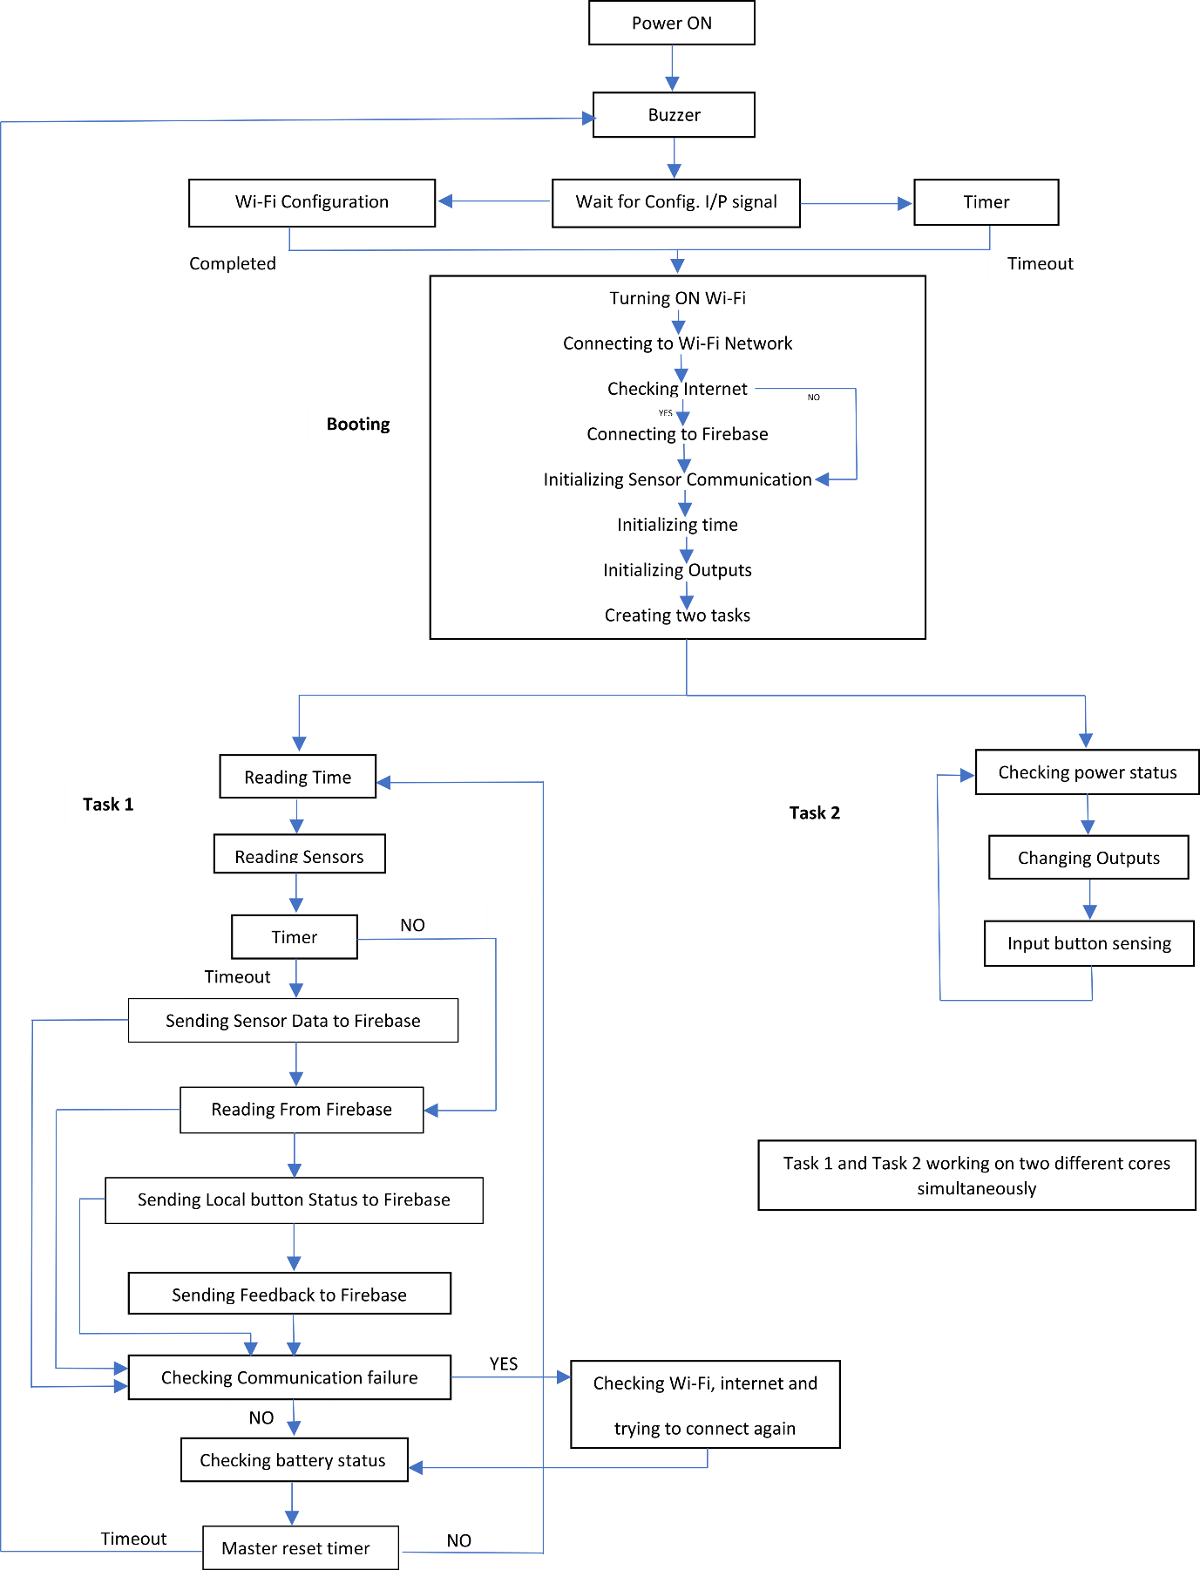

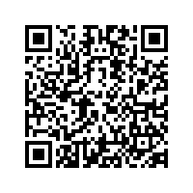

**CHAPTER – 7 XIOTAS ANDROID APP**

For downloading the Android version of the app, use below given link.

<https://drive.google.com/file/d/1s8YAoYyybdRSeN08DGqG7yMj0TDpfm_0/view?usp=sharing>

This is the Android app which is used to monitor and control the solar dryer. It is an online app which shows all the required information in the smartphone over the internet at any place where we have access to the internet. Every user has different accounts to enter into their respective device page. It will protect user data from others and keep the privacy in place. Two sign-in options are available in the app, 1st one is by creating one account and 2nd one is sign in through google. Also forgot password is available for users who have an account in it to reset their password using email. The easy and simple interface helps better user experience.

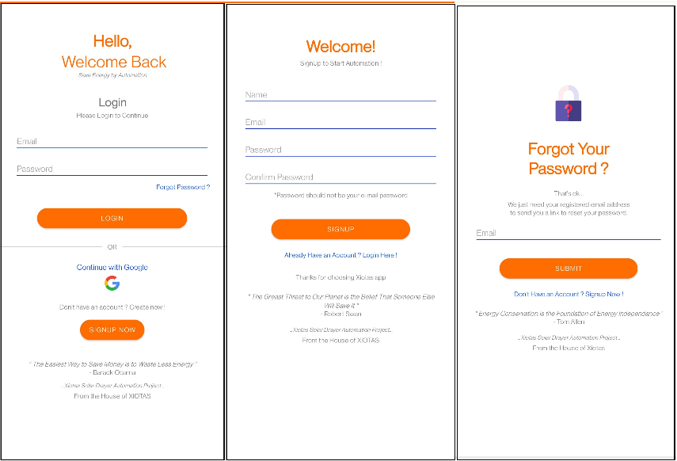

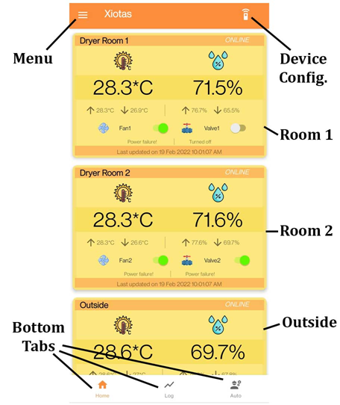The home screen contains 3 bottom tabs. Now only one is active rest all is under construction. It will update soon. The home tab contains 2 dryer room and one outside measurements and control buttons. The top left side contain the menu button. It contains some required options. The top right corner contains one device configuration. Now it is under construction. It will get ready soon.

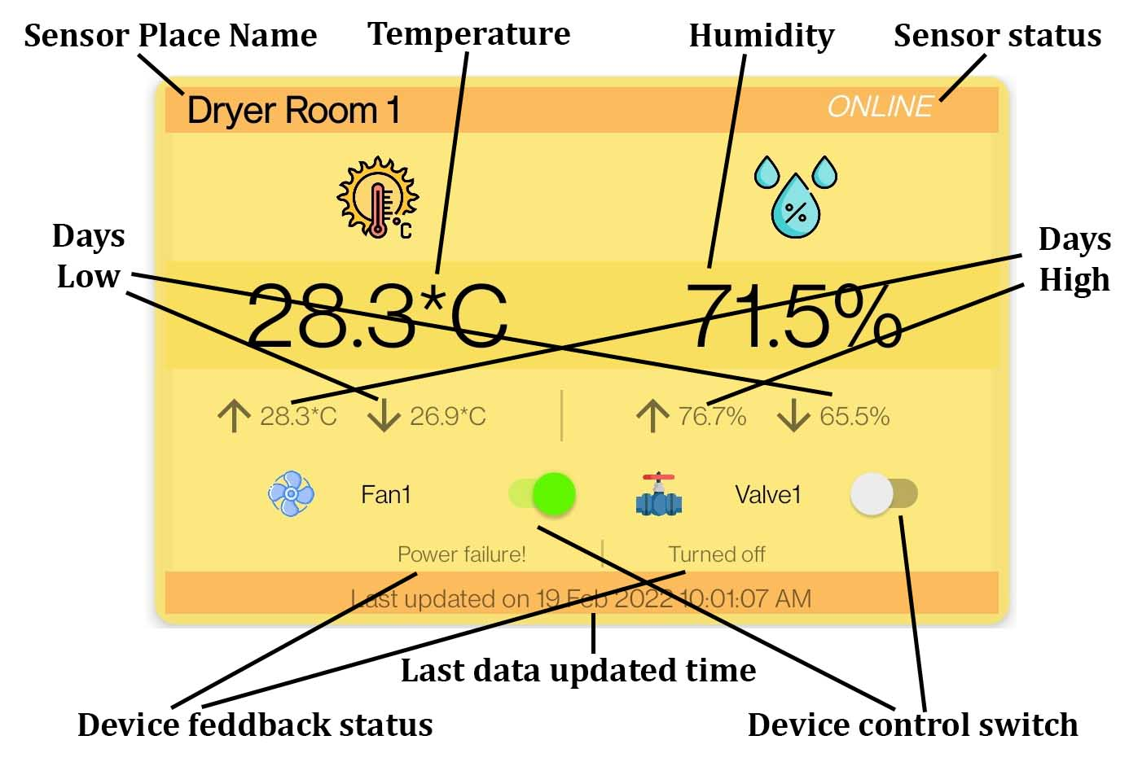The important parts in one room are marked in the given image. All the 3 sections have the same interface.

**Sensor Place Name:** It represents the place where sensor is placed. Total three places. Dryer room 1, Dryer room 2 and Outside.

**Sensor Status:** It indicates the present status off the sensor. It has two statuses either ONLINE or OFFLINE. Online means sensor is working/connected. Offline means sensor is not connected/not working.

**Temperature:** It represents the current temperature with 0.1*C resolution.

**Humidity:** It represents the current humidity with 0.1% resolution.

**Day’s High:** It represents the days maximum temperature and humidity under temperature and humidity respectively.

**Day’s Low:** It represents the days minimum temperature and humidity under temperature and humidity respectively.

**Device Control Switch:** It is for turning ON and OFF the output device. It is green colour means output is ON and grey colour means output is OFF. It is also changed based on the local button control. That is, if one output is turn on from local then it will reflect here and automatically switch will turn into green.

**Device Feedback Status:** In all time we can not trust the switch position. Sometimes it may go wrong (very less times). Because it is not feedbacked status. So, this written status represents the original output status by taking feedback from the device. The possible status is given below.

**Turned ON:** The output is in ON condition based on last data collected from device.

**Turned OFF:** The output is in OFF condition based on last data collected from device.

**Buzzing:** The output is not turned ON but it will turn ON within seconds and now the

buzzer making warning sound in device terminal. The status is based on last data collected from

device.

**Power failure:** Output is turned ON, But due to power failure at device terminal side the output

is suspended for entire power failure condition. Once the power restored, the device makes

buzzing sound (warning sound) then only the output gets activated automatically.

**Last Data Updated Time:** At any time, we cannot trust on any above data which shows on app. Because all the above data is based on last collected data from the device terminal not exactly the current data. This will happen due to lot off reasons like internet failure, device terminal failure, etc… So, this last updated time will get rid off this problem. By looking at this time and comparing with current time the user can easily verify all the data which are showing is correct or not.

*Note: Trust the measurements and status only after verifying the last updated time. Trust the output status only after looking at feedback status.*

**CHAPTER – 8 MAINTANANCE AND TROUBLESHOOTING**

**8.1 Wi-Fi Configuration**

Wi-Fi configuration is configuring the required Wi-Fi SSID (name) and password to the device for connecting into the network. It is only possible to do the configuration at the time of booting (after rest). After pressing RESET button, the device will make one beep sound and then the config. LED will turn ON. This LED indicates that the config. button is active now. By pressing the button, the device will enter into Wi-Fi configuration setup. Otherwise after few seconds the device will start booting automatically. The configuration is done by using Bluetooth communication channel. By using one app in the smartphone, it is possible to do the configuration. The procedure is given below.

The app which using for this configuration is “Serial Bluetooth Terminal”. The link is given below:

[*https://play.google.com/store/apps/details?id=de.kai_morich.serial_bluetooth_terminal&hl=en_US&gl=US*](https://play.google.com/store/apps/details?id=de.kai_morich.serial_bluetooth_terminal&hl=en_US&gl=US)

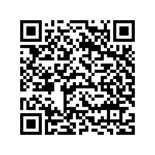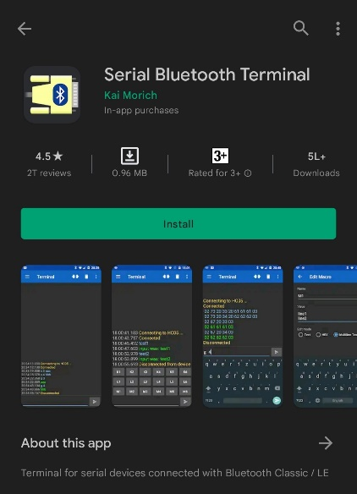

1. Download the app and install it.
2. Turn on the device if not, otherwise press RESET button once using small screwdriver after the config. LED get turned ON. Now the config LED starts blinking.
3. Turn ON Bluetooth in smartphone and pair it with “Xiotas Solar Dryer” device.

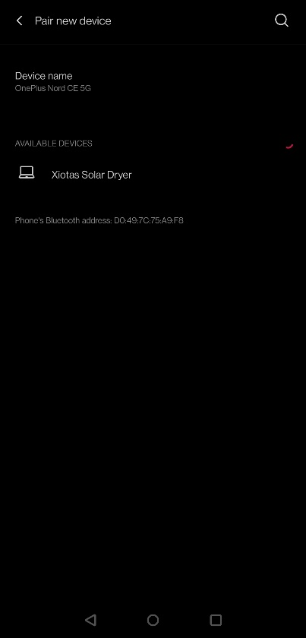

1. Open installed Serial Bluetooth Terminal app and select ‘Devices’ option from top left menu. Select ‘Xiotas Solar Dryer’ device.

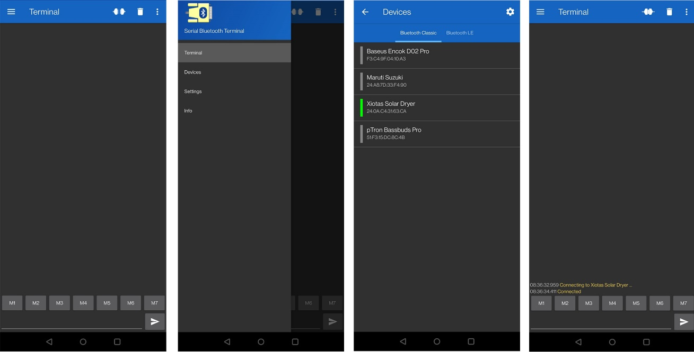

Connected

Device

Device Option

Top Left Menu

1. Type command “HELLO” in the bottom box and send it by pressing the send button right to the type box. Device will give reply for our commands (green letters in image).

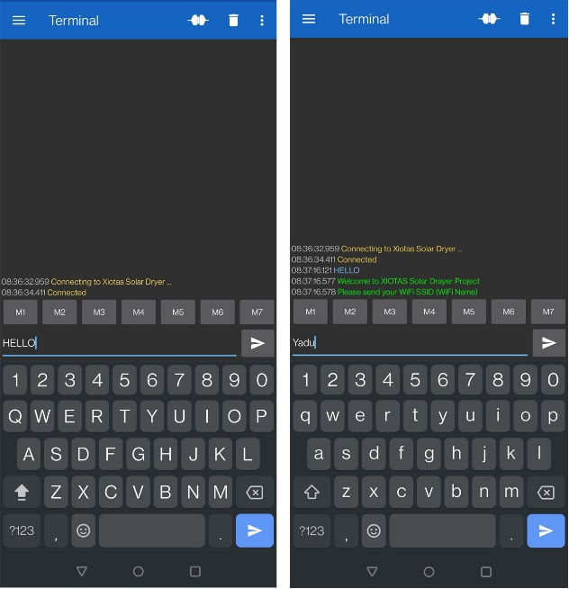

Send Button

Reply from device

1. Do all the things which replied by the device for our commands. First send SSID, then for verification send command “YES”. Same procedure for password. After that the device will turning OFF the Bluetooth and start booting automatically.
2. 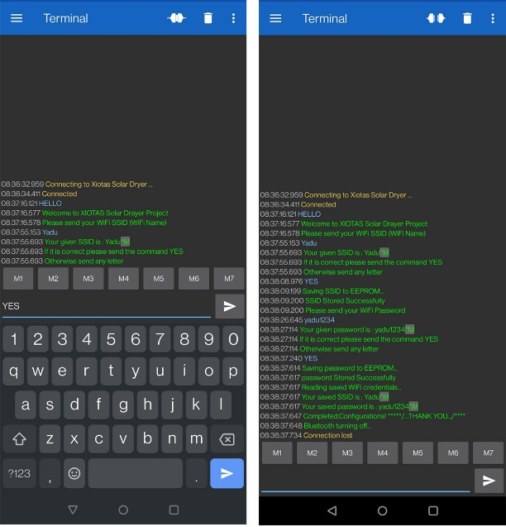Wi-Fi configuration completed.

For more reference. Watch the given video about Wi-Fi configuration. Link is given below:

<https://drive.google.com/file/d/1PygsyAjXhsd3P9MoPdaEPY3789YvfS46/view?usp=sharing>

**8.2 Mainboard Replacement**

The device contains two PCBs. One is mainboard and second one is relay board. Mainboard contain CPU and all the digital circuits. The relay board contains the control relays and is works on 230V AC. Here this procedure is explaining about replacing the mainboard which works on low voltage DC (5V). If some damage happened to the mainboard, the only one solution is to replace the PCB. The stepwise procedure is given below.

1. Turn OFF input DC 5V and disconnect the cable from the device. Turn OFF 230V input and disconnect the cable from the device.
2. Turn OFF battery backup by pushing the battery button if it is on.
3. Remove all 4 screws carefully using a screwdriver.
4. Open the top cover carefully and disconnect all the cables to the mainboard.
5. Take the front cover and place it in a safe place.
6. Remove 4 screws on the mainboard to the front cover.
7. Do all the works related to mainboard carefully. Any scratch on PCB may damage the entire PCB.
8. Takeout old mainboard from the top cover and store the screws, spacers and washers in a safe place.
9. Place the screws, washers and spacers carefully as shown in the given video and place the new mainboard in position carefully.
10. Tight the plastic screws.
11. Check the frontside push buttons for its proper operation.
12. Connect all the cables by looking at the board markings and markings on the cables.
13. Double check all the connections once again.
14. Close the enclosure carefully without damaging any cables and tight the screws.
15. Test the device by connecting to the power-supply.
16. Completed the mainboard replacement.

Watch given video for more details. Video link is given below.

<https://drive.google.com/file/d/15umOjltUzgU-7BTdZnDsNLr-i53D-TWB/view?usp=sharing>

**8.3 Troubleshooting**

|  |  |
| --- | --- |
| **Problem** | **Solution** |
| Device not turning-ON on battery backup and battery LED not lighting up | Connect device with 5V DC input and turn ON battery backup again using the battery button |
| Device is working on 5V DC but not working on battery backup. Also did above solution. | Battery or mainboard damaged. Check battery voltage. If it is less than 6V, replace it, otherwise replace the mainboard. |
| All the outputs going OFF after resetting (manual or automatic) the device | Turn it ON again from the Xiotas app |
| Sensor readings are wrong | Reset the device manually and keep it ON for a long time |
| Wi-Fi is not connecting | Do Wi-Fi configuration again |
| All sensors are connected. But, showing offline in app | Check the cable connectors. If everything is perfect, replace the mainboard |

Some more images for reference.

<https://drive.google.com/drive/folders/1t8lznxVhxbOtPUSf6TwmqOyd69f8aPlW?usp=sharing>

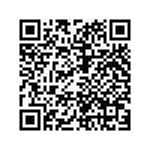

------------------------------------------------------- XIOTAS--------------------------------------------------------

---------------------------------------------------- THANK YOU ----------------------------------------------------